ICAC Moral Education e-Book
《Flying Wheels》

Name: _______________________ Class: ____________ ( ) Date:__________________

What’s wrong?
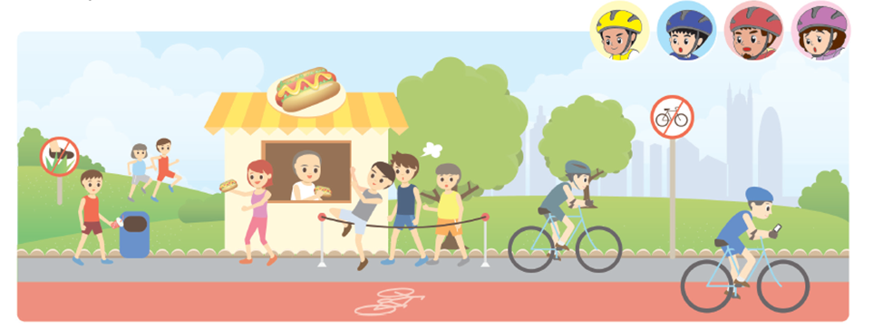
In the picture below, circle those who fail to observe the rules.
The wrong behaviours include:
1. __________________________________________ 2. __________________________________________
3. __________________________________________ 4. __________________________________________

Fill in the Blanks
Why do we need to observe the laws and the rules? Think about the consequences of breaking the following laws / rules.
 | Laws / Rules | Consequences of breaking them
Example | Pedestrians and motorists should obey traffic regulations. | Endangering the lives of oneself and the others.
1 | No smoking is allowed in public indoor places.
2 | Passengers of public transportation should queue up for boarding.
3 | Keep quiet in the libraries.
ICAC Moral Education e-Book Website: http://www.me.icac.hk/icac/ebook2015/en/index.html

