ICAC Moral Education e-Book
《Flying Wheels》

Name: _______________________ Class: ____________ ( ) Date:__________________

What’s wrong?
In the picture below, circle those who fail to observe the rules.
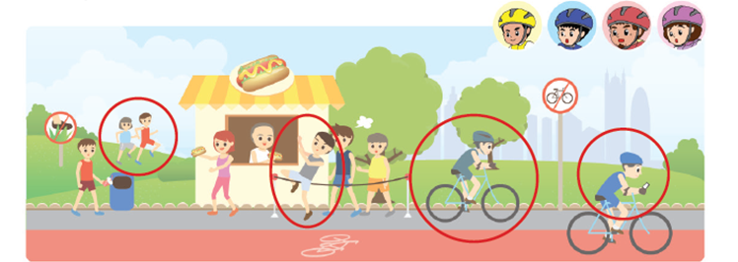

The wrong behaviours include:
1. _Stepping on the grass_________________________ 2. _Jumping the queue_________________________
3. _Cycling on pedestrian paths____________________ 4. _Playing with mobile phone while cycling________

Fill in the Blanks
Why do we need to observe the laws and the rules? Think about the consequences of breaking the following laws / rules.
 | Laws / Rules | Consequences of breaking them
Example | Pedestrians and motorists should obey traffic regulations. | Endangering the lives of oneself and the others.
1 | No smoking is allowed in public indoor places. | Affecting others’ health/ polluting the air/ causing fire
2 | Passengers of public transportation should queue up for boarding. | Passengers push each other and some may get injured
3 | Keep quiet in the libraries. | Disturbing other readers in the libraries
ICAC Moral Education e-Book Website: http://www.me.icac.hk/icac/ebook2015/en/index.html

