ICAC Moral Education e-Book
《Magical Running Shoes》

Name: _______________________ Class: ____________ ( ) Date:__________________

Story Sequencing
Try to arrange the following pictures according to the order of events in the story.

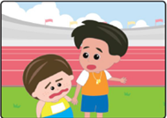  A |  | 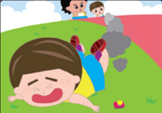  B |  | C
Teacher said Simon could not represent the school because he cheated. |  | When Simon pressed the button to accelerate, he lost balance and fell on the ground. |  | Little monster suggested Simon to wear magical running shoes for the competition.
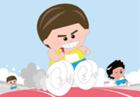  D |  | E |  | F
Simon ran exceptionally fast with his magical shoes. |  | Simon threw the magical shoes away and was determined to put in effort in training. |  | Simon came last in the group training.
The order of events should be：
1. ( ) 2. ( ) 3. ( ) 4. ( ) 5. ( ) 6. ( )

Maze Game
Simon realised the importance of fair competition and sportsmanship. He was determined to strive to become the Champion with his own abilities. Would you help him run out of the maze below?
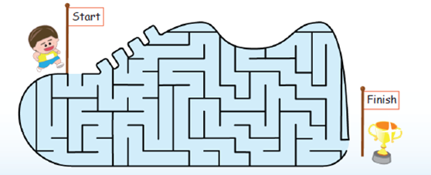
ICAC Moral Education e-Book Website: http://www.me.icac.hk/icac/ebook2015/en/index.html

