ICAC Moral Education e-Book
《Karen and Grandmother》

Name: _______________________ Class: ____________ ( ) Date:__________________

Matching
Draw lines to match each picture with the correct description below. In the space provided, draw for Karen’s good behaviours and draw for her bad behaviours.
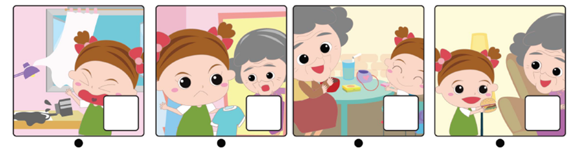

Karen lost her temper with Grandmother who forgot to wash PE uniform. | Karen gave Grandmother a burger and said sorry to her. | Karen was considerate to Grandmother and gave her walnut cakes and a little bag with reminder labels. | Karen shouted loudly at Grandmother when she found that the windows were open.

Thank You Card
Design a card to express your gratitude to someone you love and respect.

Dear Grandma,

Thank you for ___ taking care of me___ !_

I promise I would __be a good kid.____
Love,
___Karen__

(Please cut the pictures below for decorating your card.)

ICAC Moral Education e-Book Website: http://www.me.icac.hk/icac/ebook2015/en/index.html

