ICAC Moral Education e-Book
《The Lost Eraser》

Name: _______________________ Class: ____________ ( ) Date:__________________

Story Sequencing
Try to arrange the following pictures according to the order of events in the story.
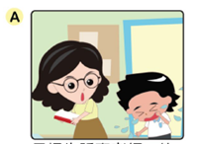 |  | 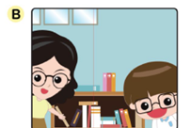 |  | 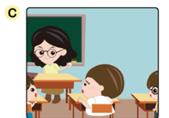
Tom told Miss LI that he had lost his eraser. |  | To make up for his mistake, Henry helped Miss LI tidy up the bookshelves. |  | Miss LI told the class to help search for Tom’s eraser.
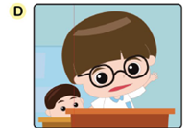 |  | 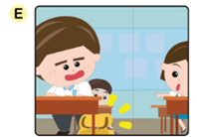 |  | 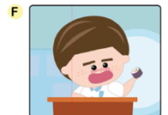
Henry confessed that he took Tom’s eraser. |  | Kitty found the eraser in Simon’s school bag. |  | Simon said he didn’t take Tom’s eraser.

The order of events should be：
1. ( A ) 2. ( C ) 3. ( E ) 4. ( F ) 5. ( D ) 6. ( B )

Colouring
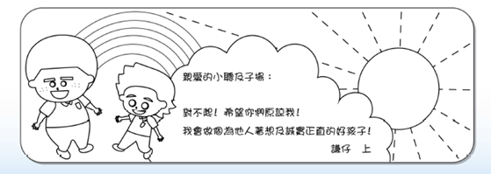
Henry would like to send a bookmark to his classmates to apologise for what he did and commit to be an honest and considerate boy. Please colour the bookmark below designed by Henry.
ICAC Moral Education e-Book Website: http://www.me.icac.hk/icac/ebook2015/en/index.html
Dear Tom and Simon,
I am really sorry! Please forgive me! I promise to be an honest and considerate boy from now on!
Henry

