ICAC Moral Education e-Book
Mai Po Visitors

Name: _____________________ Class: __________ ( ) Date:_________________

Do’s & Don’ts
Describe what the animal kids are doing. Put a ‘’ in the box if you think the behavior is correct, and a ‘’ if it is incorrect.

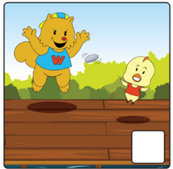 | 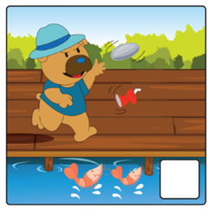 | 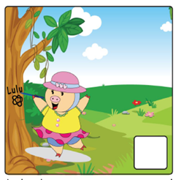
Chickeebee and Walala ran and _______ one another on the ________. They ______ and laughed loudly. | Dingy Dog threw _______ and _______ into the _____________________. | Lulu drew _________ and carved ________ on the __________________.
Fill in the Table
Have you ever seen the following signs? Please state in the table below where these signs can be found and the meaning of these signs.

 | Signs | Place(s) where the sign can be found | Rules
Example |  | Parks | No flower picking
1 | 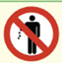 | Parks, beaches, etc. | Don’t _____________________
2 | 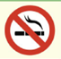 | Cinemas, restaurants, etc. | No _______________________
3 | 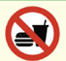 | Buses, MTR, libraries, etc. | No _______________________
4 | 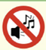 | Libraries, cinemas, concert halls, etc. | Keep ______________________

