ICAC Moral Education e-Book
Pocket Money

Name: _____________________ Class: ___________ ( ) Date:__________________

Fill in the Blanks & Story Sequencing
Describe the events shown in the pictures below by filling in the blanks. Write down 1, 2, 3 or 4 in the boxes to show the correct sequence of the story.

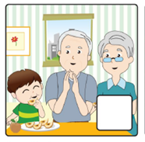 |  |  |  | 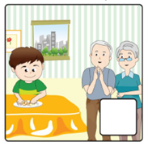
Grandfather ______ and _______ the pears for Timmy. |  | Timmy suggested to help doing _____ and asked grandmother to give him _______ in return. |  | Timmy helped Grandparents to _______ up the peels on the ________ . |  | Grandmother served Timmy a _______ of Chinese ________.

Is Money Almighty?
Try to identify which of the following items can / cannot be bought with money by putting them into the table below.
Time Mobile phone Clothes
Love Stationery Friendship
Snacks Wisdom Watch
Health Toys Trust

Things which CAN be bought with money | Things which CANNOT be bought with money

Do you think ‘money is almighty’? Why?
_____________________________________________________________________________________

_____________________________________________________________________________________

