答案

廉政公署德育電子故事書
《選舉小風波》

姓名: __________________________ 班別: _______________ ( ) 日期:__________________

找對錯
以下哪些是同學做得對的事情? 哪些是破壞廉潔選舉的行為? 做得對的，請在空格內填上「」，做得不對的，請填上「」。

 |  | 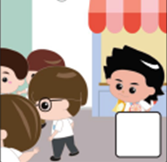
子揚請同學吃零食，要同學選他做班長。 |  | 同學知道子揚請吃零食是為了換取選票，都紛紛拒絕。 |  | 同學投票給有才能和服務精神的熙熙，選他做班長。 |  | 子揚在演辭中誇說自己為班做了很多事，希望同學投票給他，但其實他並沒有做過。

找字遊戲
完成工作紙後，請邀請家長在空位上加上「」號，以表示支持廉潔及公平的選舉。

競選要公平，要憑實力，絕不能以不法手法取勝啊!  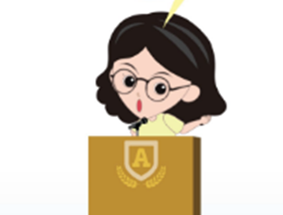 | 你能從以下找到「公平」兩個字嗎？請把它們圈出來 (提示：共有五個)。
風 | 有 | 實 | 正 | 憑 | 行 | 班 | 小
為 | 說 | 公 | 廉 | 力 | 班 | 平 | 選
公 | 平 | 力 | 潔 | 勝 | 公 | 誠 | 正
小 | 選 | 班 | 波 | 廉 | 潔 | 長 | 實
老 | 長 | 風 | 力 | 風 | 公 | 誠 | 平
才 | 憑 | 行 | 選 | 平 | 實 | 班 | 波
廉 | 平 | 服 | 舉 | 有 | 長 | 公 | 為
務 | 能 | 才 | 平 | 能 | 師 | 平 | 舉

