廉政公署德育電子故事書
答案
《神奇跑鞋》

姓名: ________________________ 班別: _______________ ( ) 日期:_____________________

故事重組
試根據故事，把以下圖畫順次序排列起來。

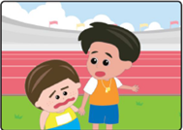  A |  | 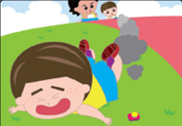  B |  | C
老師說小聰沒有體育精神，沒資格代表學校出賽。 |  | 準備衝線之際，小聰按鈕加速，失去平衡跌倒在地上。 |  | 小魔怪提議小聰穿神奇跑鞋比賽，不用練習也可拿冠軍。
D |  | 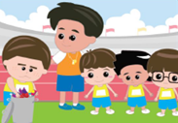  E |  | 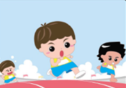  F
小聰穿上神奇跑鞋，在比賽中遙遙領先。 |  | 小聰向眾人道歉，並丟棄了神奇跑鞋，決定要努力練習，靠實力爭取第一名。 |  | 小聰在小組比試練習中敗給熙熙和子揚。
事件發生的次序是：
1. ( F ) 2. ( C ) 3. ( D ) 4. ( B ) 5. ( A ) 6. ( E )

迷宮遊戲
小聰得到教訓了，他明白到公平競賽的重要。小聰要憑實力重新跑一次，你可以幫他跑出這個迷宮嗎？
